**Analysis of Latitude’s Influence in Weather Patterns**

This report lists conclusions reached from an analysis of worldwide temperatures, humidity, wind speed and cloud cover by latitude

BACKGROUND:

To analyze how weather patterns are affected by latitude, the present report is based on 540 cities chosen randomly (by generating random coordinates, searching for the closest city and then eliminating the resulting cities that are not listed in our weather API (OpenWeather). Temperature, humidity, wind speed and cloud cover measurements were taken for each of these cities and then plotted against latitude to understand how the latter affects the former

CONCLUSIONS:

KEY HIGHLIGHTS:

1. Temperature is noticeably affected by latitude. Specifically, the area contained between the Tropic of Cancer (23.5 degrees north of the Equator) and the Tropic of Capricorn (23.5 degrees south of the Equator), commonly referred to as the Tropics, have temperatures similar to those in the Southern Hemisphere below the Tropic of Capricorn. This area, where seasons are noticeable and which are in summer during this time of year, could be expected to be warmer that areas close to the Equator but in general have similar temperatures. The land further north of the tropic of Cancer, is clearly in winter, with temperatures in a range between 10 and -40 degrees centigrade
2. The latitude vs temperature graph seems to indicate a greater concentration of cities in the northern hemisphere vs the southern hemisphere. To ascertain whether this is true or whether the southern hemisphere has smaller cities that are more likely to be unavailable in the OpenWeather API, a search of land mass and cities in each hemisphere confirms the truth of our visual observation. Specifically, 68% of earth’s land mass and 88% of it’s population is concentrated in the Northern Hemisphere

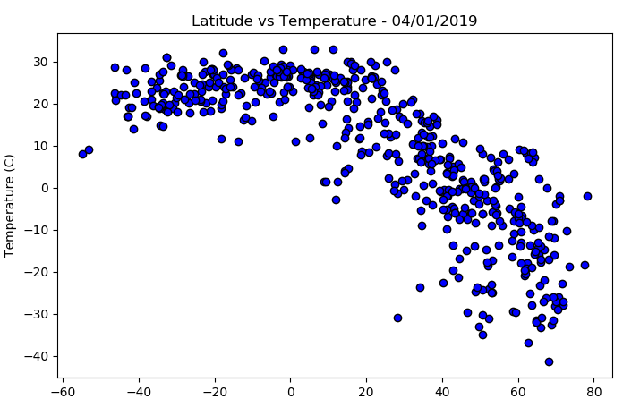

1. The effect of latitude on humidity is not apparent in our analysis. Despite the fact that warm air is capable of holding more water than cold air, our latitude vs humidity graph shows similar humidity levels across latitudes. The higher concentration of cities in the northern hemisphere is visible but humidity levels across the globe are concentrated around 80%, with most cities within aa 65 to 80% range

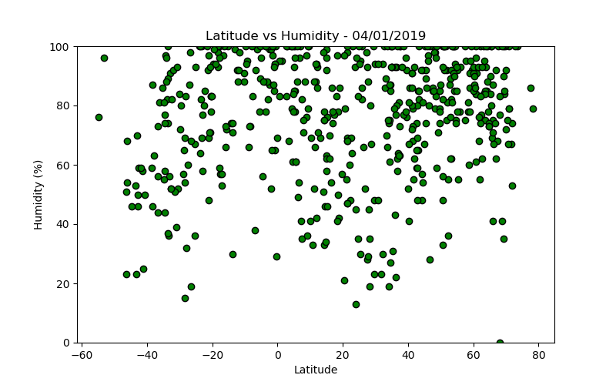

1. Wind speeds across latitudes concentrate around 2m/sec and are mostly below 4m/sec, limiting the possibility of strong growth in the home wind powered electricity generation industry, in the near term. Considering that current technology requires a minimum wind speed of 4m/s for small generators and 6m/s for industrial systems, wind powered electricity will remain the domain of large wind farms in rural areas with strong winds.

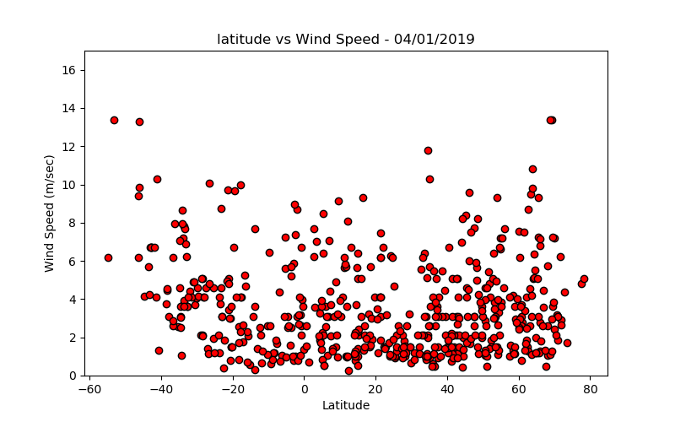

1. Cloud cover appears to be unrelated to latitude. Cloud cover varies throughout the world, with slightly stronger concentration around 0% and 90% but no clear correlation with latitude is visible.

